Q. Create 2 VNET, each with their own subnet. Create a VM in each of them and SSH into the VMs from the Azure CLI. Also, enable ICMP protocol to ping the VM’s public IP from each VM.

Configure VNET Peering so that the VM’s can communicate using private Ips

Step 1: Login to the Azure CLI

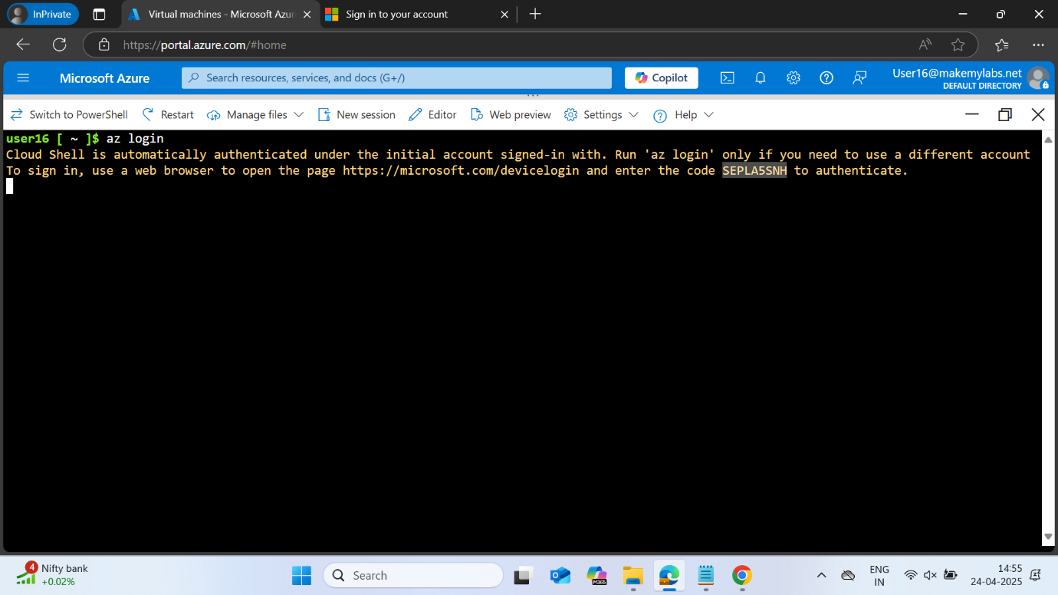

Open the new page and copy the code displayed to successfully login

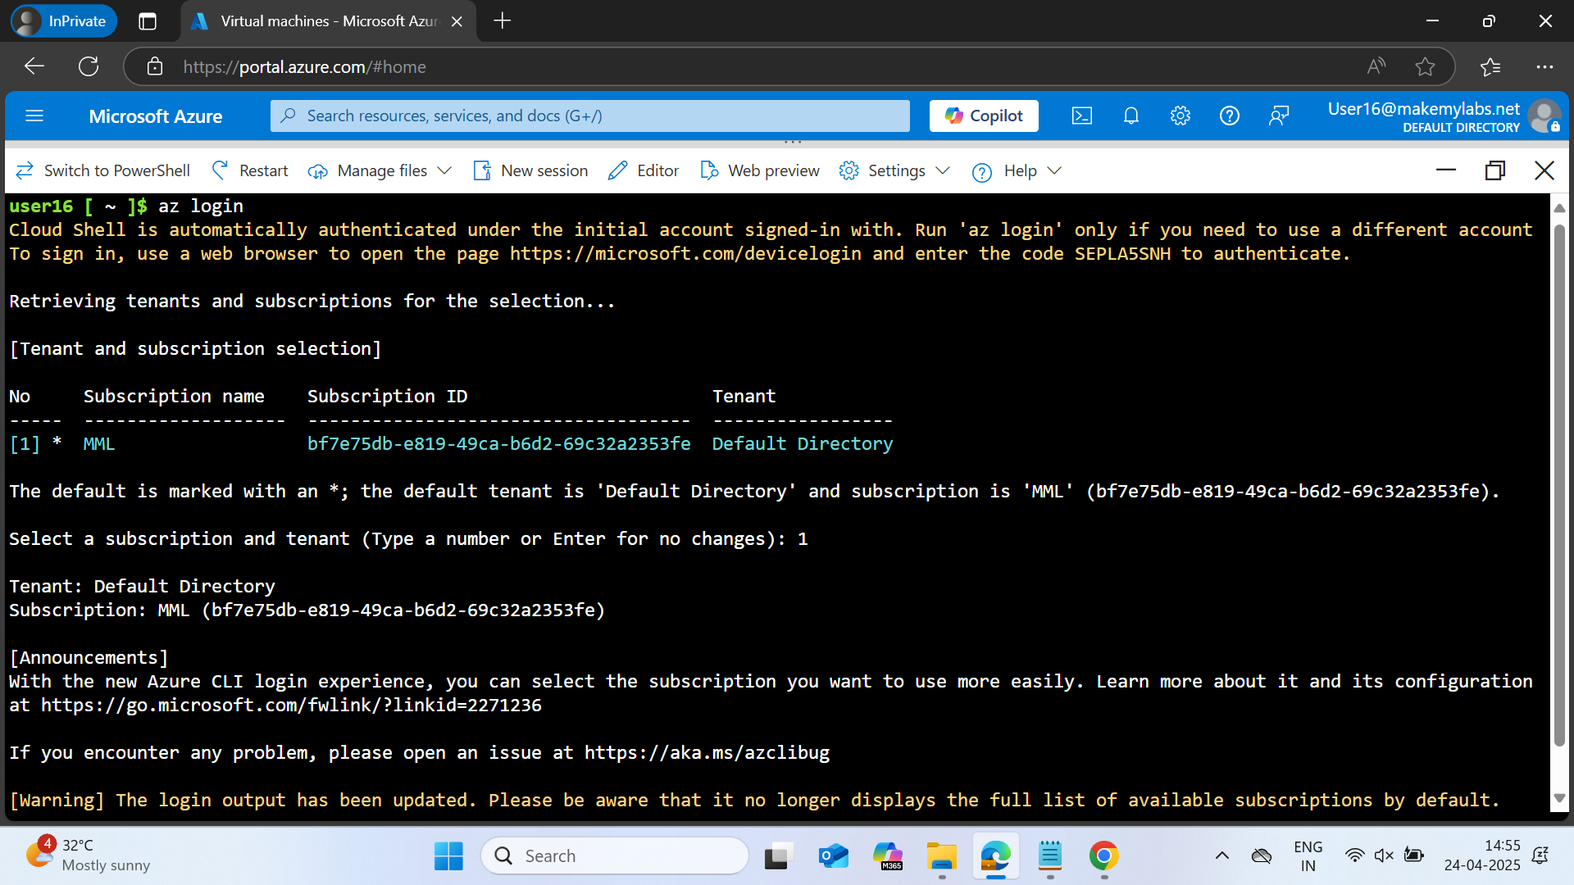

Step 2: Create 2 VNETs by specifying the resource group, VNET name and the address prefix.

Note: We need to have the resource group made prior to executing this step.

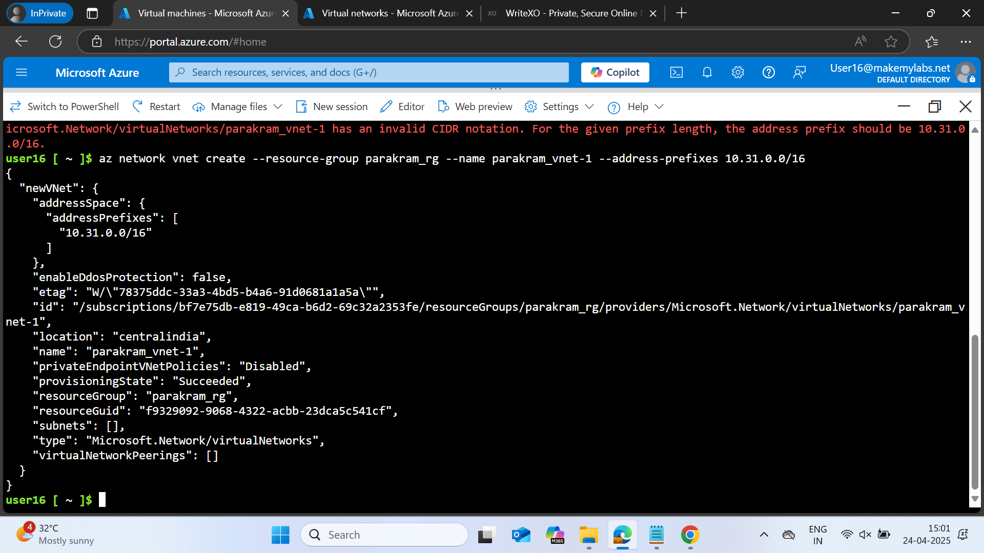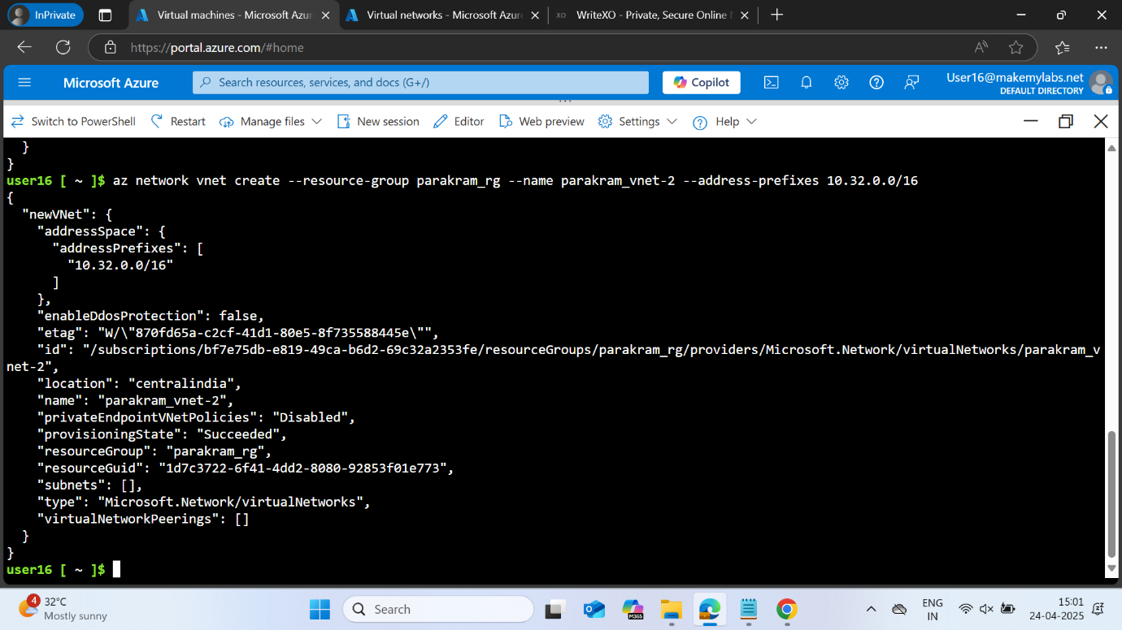

Step 3: Create subnets in each of the VNETs by specifying the subnet name, VNET name, resource group and the address prefix

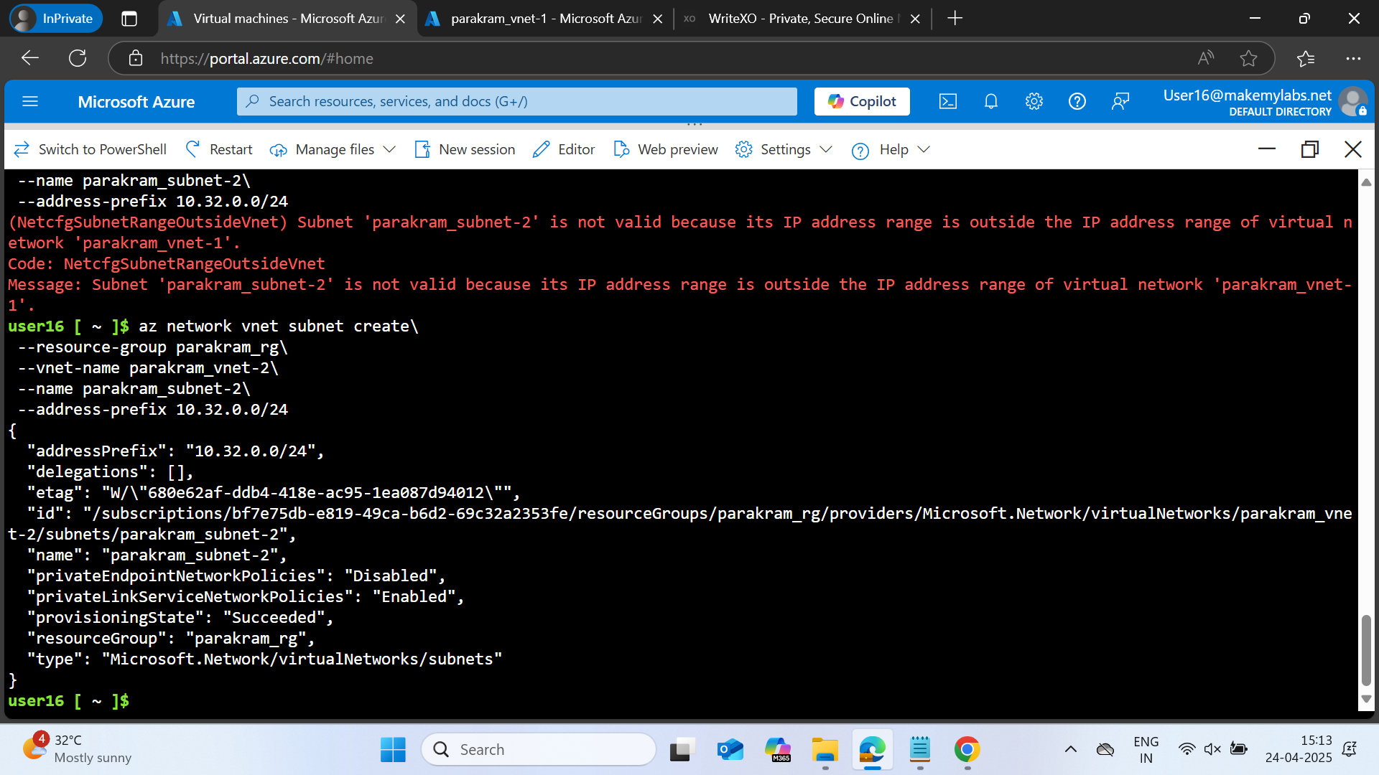

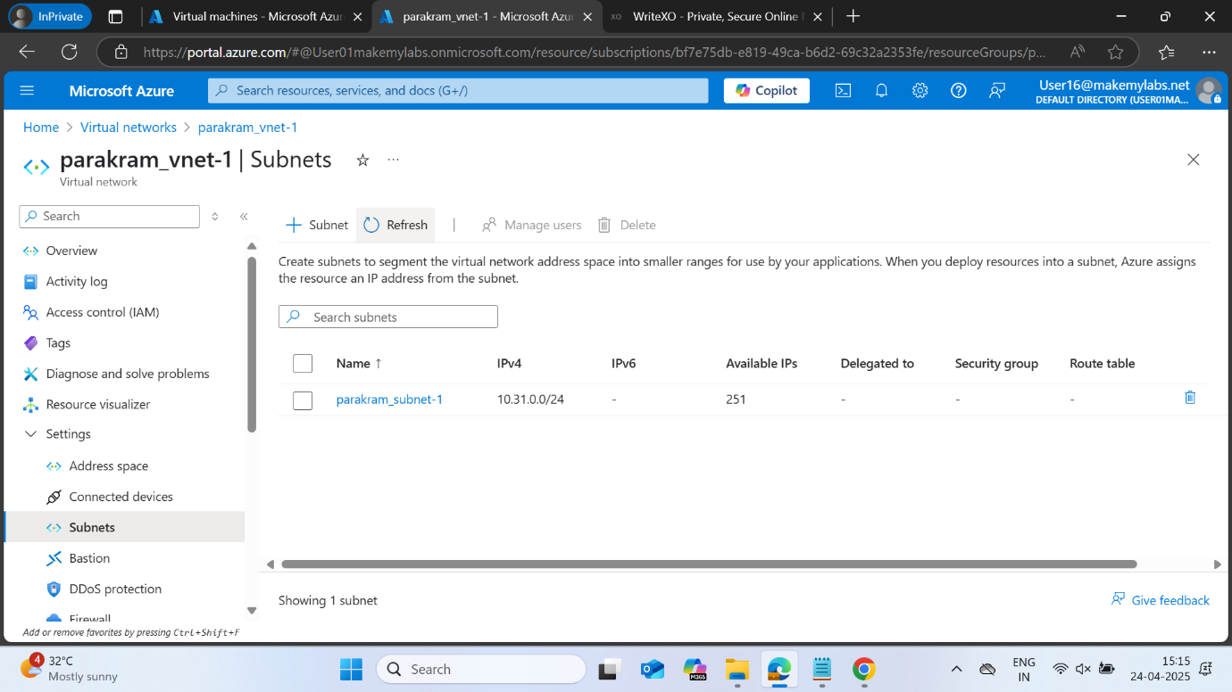

Step 4: Create a VM in each of the subnet by specifying the resource group, location, name, image(has to be specified), size(has to be specified if the default one isn’t available in the region), vnet name, subnet name, admin username and pwd.

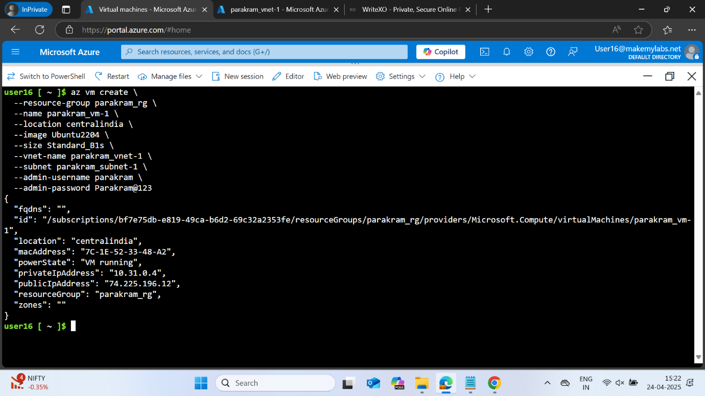

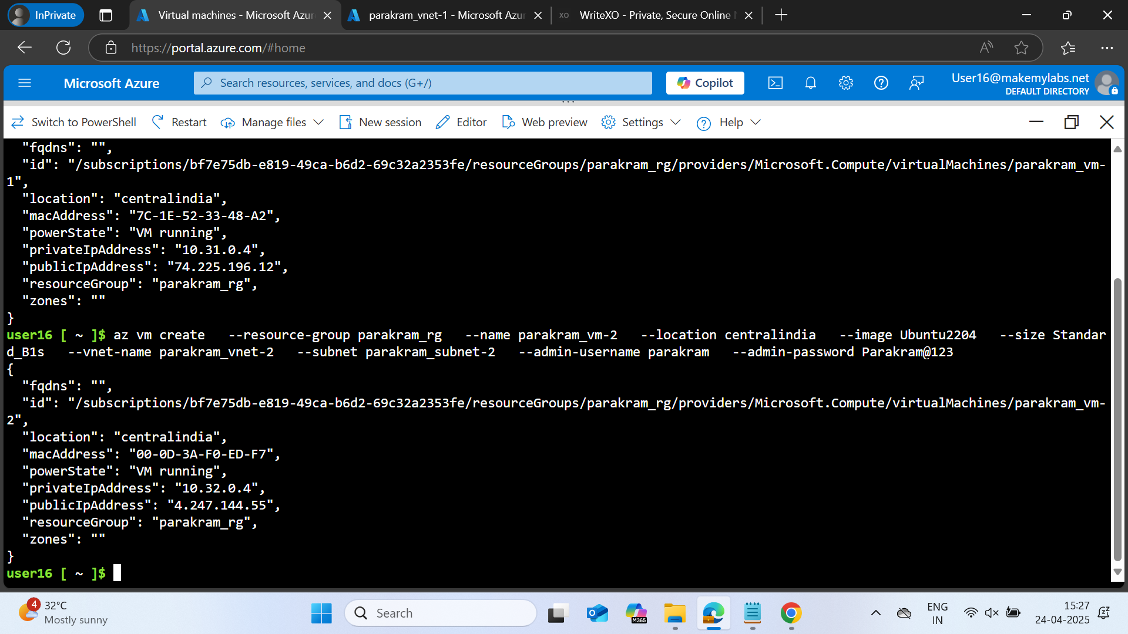

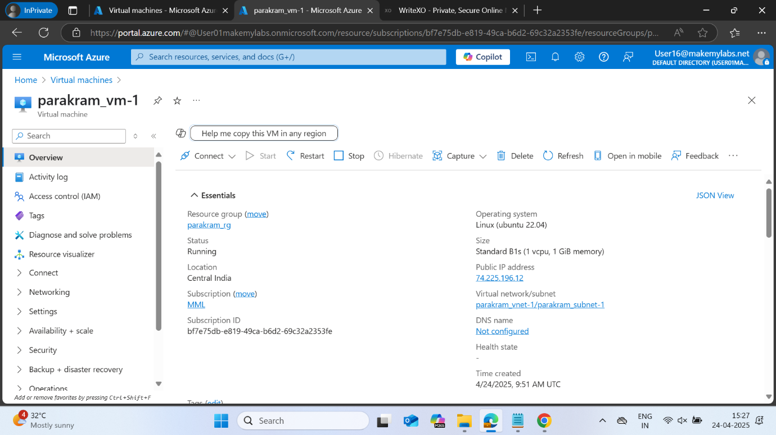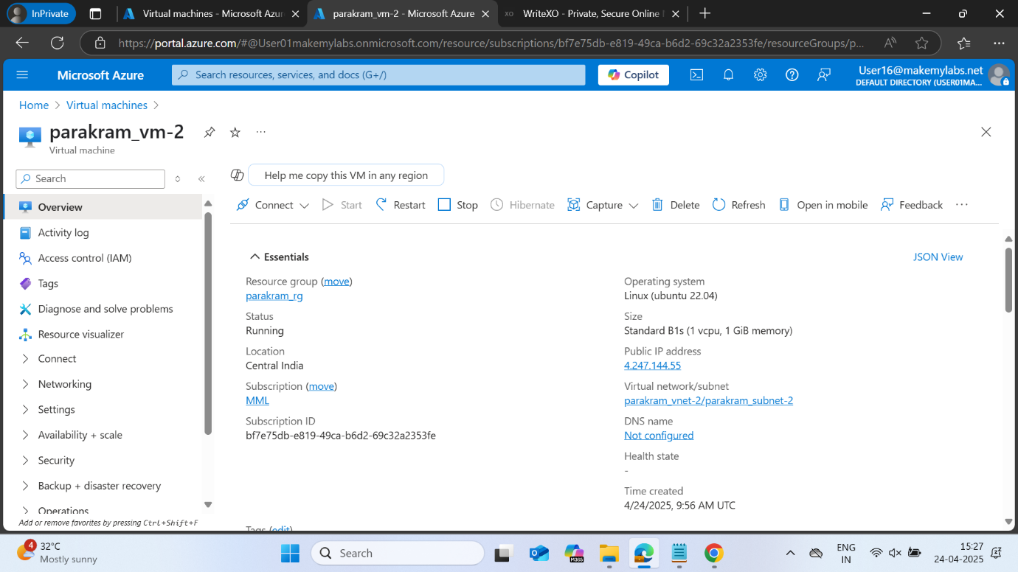

Step 5: Upload the .pem file and SSH into the VM

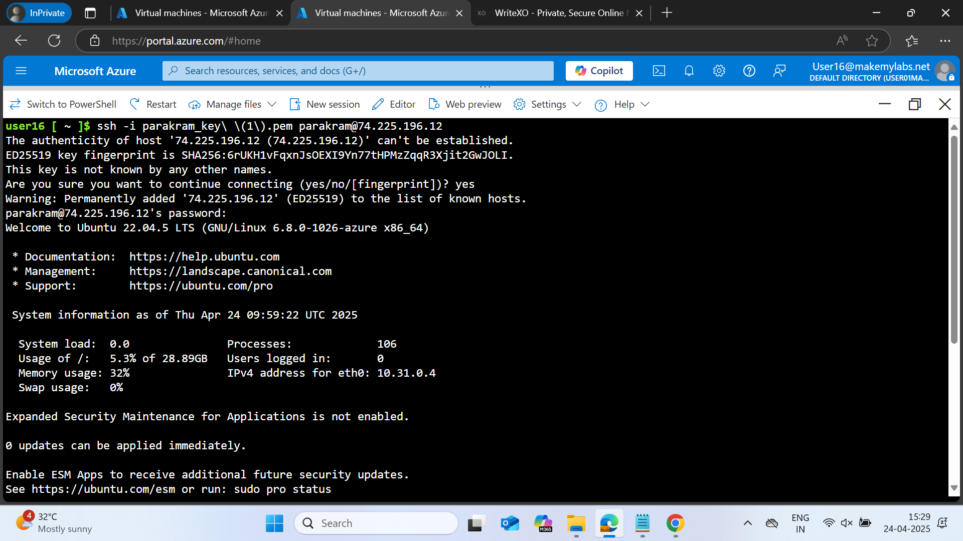

Step 6: In order to ping the VM from another machine, add an inbound rule to allow ICMP protocol from all sources

